

Internship FSD v0.4.1

**Revision History**

| Date | Version | Description | Author |
| --- | --- | --- | --- |
| 2015-06-29 | 0.1 | First Draft | Madalin Sandu |
| 2019-05-05 | 0.2 | Second Draft | Volodymyr Lysenko |
| 2019-05-16 | 0.3 | Third Draft | Denys Arkan |
| 2019-06-18 | 0.4 | Added 4.6 + Updated 7 (bullet point + module) | Volodymyr Lysenko |
| 2019-06-24 | 0.4.1 | Fixed 7.1 in PSD, added 3.3 | Volodymyr Lysenko |

**Table of content**

1. Introduction 4
2. General requirements 5
3. Global Elements 6
   1. Header 6
   2. Navigation 6
   3. Navigation on Mobile………………………………………………………………………………………………………………….6
   4. Footer 7
4. Product Tile 8
5. Homepage 9
   1. Carousel Banner 9
   2. Popular Items 9
   3. Full Image Banner 10
   4. Featured Products 10
   5. Benefits Content 10
6. Category Landing Page 11
   1. Breadcrumbs 11
   2. Filters 11
7. Product Detailed Page 12
   1. Product Image 12
   2. Product Details 12
   3. Tabs 13
8. Non-Product Pages 14
   1. 404 Page 14
   2. Log in Dialog 14
   3. Cookies Policy 14
   4. Countdown Page (bonus task) 15
   5. Cart Page (bonus task) 15
   6. Print Page (bonus task) 16

## Introduction

The basic reason of this Functional Specification Document is to provide the requirements for final Front-End Project. The intern by the end of the course should gain general skills about the workflow and technologies used in daily basis and improve learning skills, by doing researches and choose self-learning path.

The developer’s tools and libraries/frameworks should be chosen by the intern individually, the restriction is only requirements mentioned in FSD.

The project progress is recommended to be done in the order described in FSD. The functionality is described in the order to be reused from previous to next steps, and this will give a boost for accomplishment.

**For the missing sections, breakpoints, the developer should take decisions regarding the layout and how it should look.**

**The requirements in FSD has more priority over the design provided. In case there is a deviation between FSD and Design, the written requirement should be implemented.**

**Bonus tasks are optional for completing and can be completed only after all the rest requirements are done. In case the intern will complete the additional tasks, this will be a big bonus for the final grade. In case the bonus tasks are not completed, this moment shouldn’t affect the final grade.**

The final project must be delivered in the deadline established and should be provided the step by step instruction how to run the project on another machine in order work to be validated, also all source files to be pushed to Git repository.

## General Requirements

**Technologies to be used:**

* HTML5 (Validation, Cookies, Local Storage, Bowser API);
* CSS3, SASS (Autoprefixer);
* JavaScript (jQuery);
* NPM/Yarn;
* Gulp/Webpack;
* Responsive:
  + Homepage 1280px for screens that are bigger than 1280px, fixed layout (**PSD provided**);
  + Homepage 768px for screens that are between 768px and 1280px, fixed layout (**PSD NOT provided).** Layout presentation will be adjusted by developer);
  + Homepage 320px for screens that are between 320px and 768px, fluid layout. (**PSD provided**);
* GIT: the project will be hosted on GIT;
* Photoshop (to slice and extract the images, color picker, measurement);
* Code Editor (Visual Studio Code);

**Browser compatibility:**

* Chrome last version (required);
* Firefox last version (required);
* Safari last version (optional);
* IE11, Edge (optional);
* Last versions of mobile browsers (required);

**Bonus Points (optional technologies):**

* Mobile First approach;
* CSS Methodologies as BEM, SMACS;
* CSS Frameworks and Grid (Bootstrap, Foundation, Flexgrid);
* JS next (ES6+);
* JS Frameworks (React, Vue) - for bonus task only;
* Code Style guide (Airbnb for JS/CSS);
* Code Documentation (JSDoc for JS);

## Global Elements

* 1. **Header**

Required header to be fixed.



1. *HEADER_1*. Logo should be text with Brand icon, clicking on it redirects the user to the Homepage.
2. *HEADER_2*. Navigation. Hover state required. For elements marked as drop-down, on click/hover show drop-down menu.
3. *HEADER_3*. Login or Register. Click on it opens the Login pop-up. Form to be created by developer accordingly to design provided in section *8.2. Log in Dialog*.
4. *HEADER_4.* Wishlist. Indicates a number of products in wishlist, icons should be implemented with fonts, hover state required.
5. *HEADER_5*. Mini-cart. Indicates a number of products in the cart, icons should be implemented with fonts, hover state required.
   1. **Navigation**

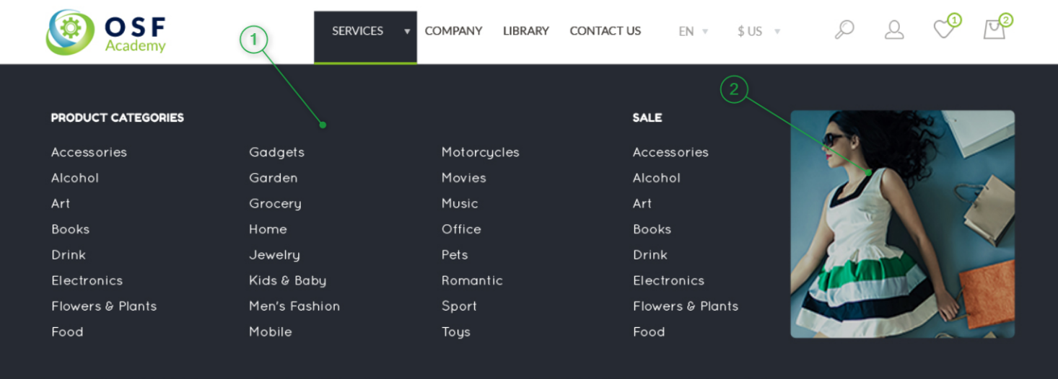

1. *NAVIGATION_1*. Mega Menu. All links should redirect to 404 page created by developer by design provided in section *8.1. 404 Page*.
2. *NAVIGATION_2*. Featured Image. No special functionality required.

**3.3 Navigation on Mobile**

First level Second Level Third level

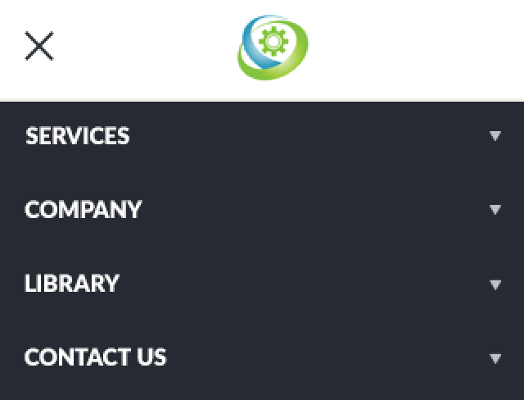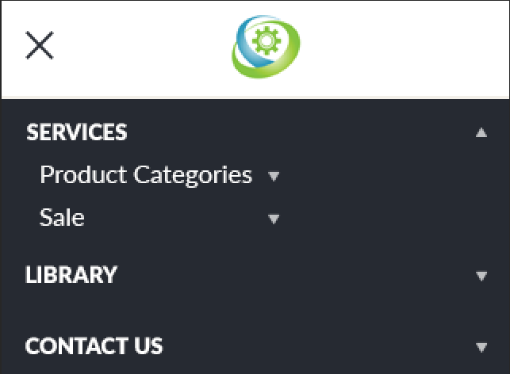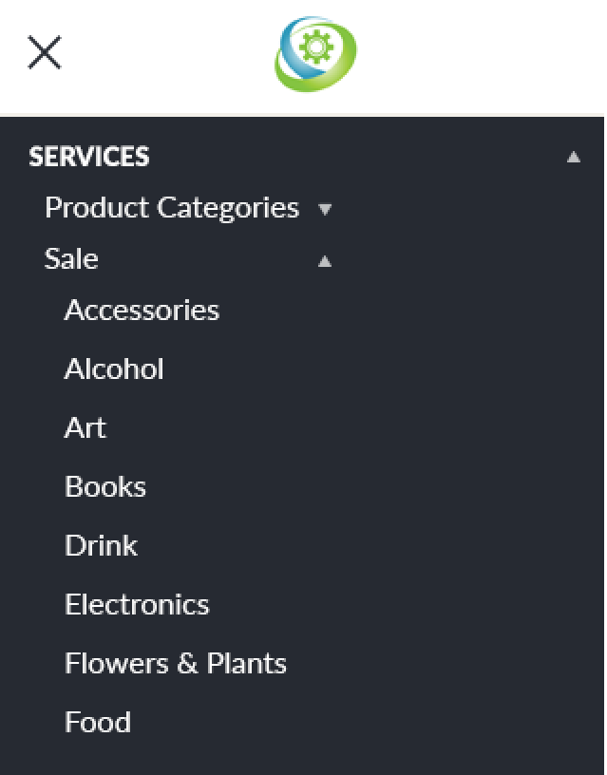

* 1. **Footer**

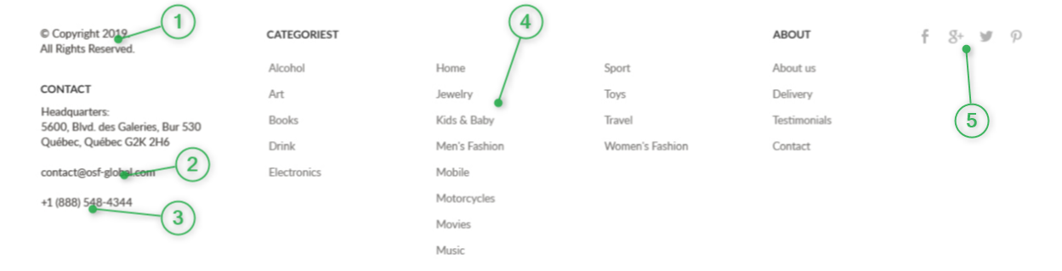

1. *FOOTER_1*. Year. Current year to be injected by JS.
2. *FOOTER_2*. Email link. By clicking on the link, activate the default mail client on the computer for sending an e-mail.
3. *FOOTER_3*. Phone. By clicking on the link to open default OS software to make a call.
4. *FOOTER_4*. All links should redirect to 404 page created by developer by design provided *8.1. 404 Page*.
5. *FOOTER_5*. Social Links. By clicking on the links, should open external Social Network page.

## Product Tile

* 1. **Product Tile**

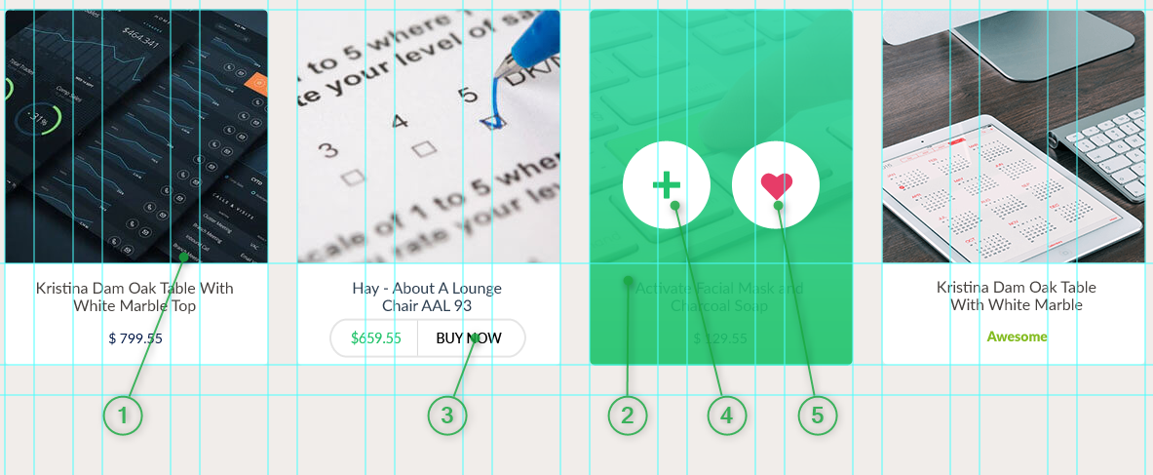

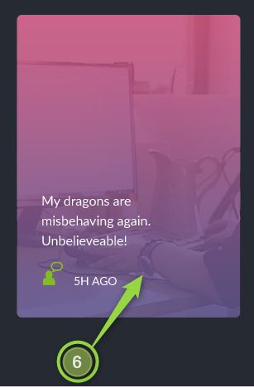

1. *PRODUCT_TILE_1*. By hover over the product tile, show the overlay with “plus” and “heart” buttons described in *PRODUCT_TILE_2**.*
2. *PRODUCT_TILE_2*. The hover state over product tile, show the overlay with CSS gradient and clickable buttons.
3. *PRODUCT_TILE_3*. Buy now button. By clicking on the button increase the number for Minicart element from the header *HEADER_5*. The product tiles with current button should NOT follow hover rule as *PRODUCT_TILE_1*. But by clicking on the product name, price or image, redirect the user to Product Detailed Page developed by the design provided in section *7. Product Detailed Page*.
4. *PRODUCT_TILE_4*. Add to cart button. By clicking on the button increase the number for Minicart element from the header described in section *HEADER_5*.
5. *PRODUCT_TILE_5*. Add to Wishlist button. By clicking on the button increase the number for Wishlist element from the header described in section *HEADER_4*.
6. PRODUCT_TILE_6. Will be a static element, which doesn’t reflect on hover event.
   1. It consists of: Image, Text + Gradient Overlay.

## Homepage

* 1. **Carousel Banner**

Required 3 types of text alignment for carousel content: left, center, right.



1. *CAROUSEL_1*. View More link. By clicking on the link redirect the user to Category landing page developed accordingly design provided in section *6. Category Landing Page*.
2. *CAROUSEL_2*. Carousel controls. By clicking on the controls show respective slide. Active state required.
   1. **Popular Items.**

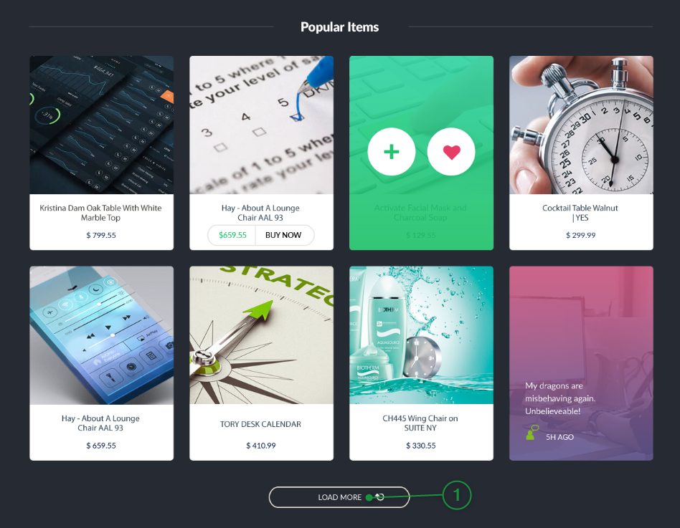

1. *POPULAR_ITEMS_1*. Load More button. By clicking on the button, load 4 more products. Note: the product data should be coming from JSON file via AJAX request. In JSON file can be saved product name, price, image URL, etc.
   1. **Full Width Image (no special functionality required).**



* 1. **Featured Products**

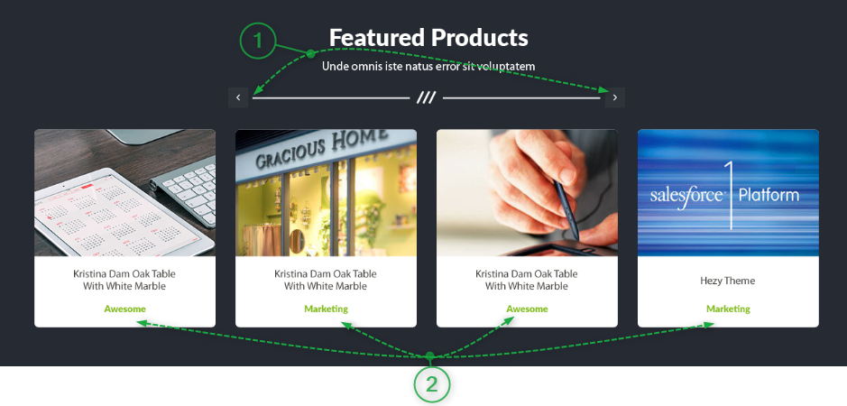

1. *FEATURED_PROD_1*. The slider controls. By clicking on the next/prev buttons, should scroll to next 4 products. The carousel should load every 5 seconds next set of the products.
2. *FEATURED_PROD_2*. To be used product tiles developed in the section *PRODUCT_TILE_3*.
   1. **Benefits Content (static content).**



## Category Landing Page

* 1. **Breadcrumbs**



1. *BREADCRUMBS_1*. By clicking on the link, redirect the user to dedicated page. Hover state required.
2. *BREADCRUMBS_2*. The last Breadcrumbs element shouldn’t be clickable, also don’t have hover state. Note: the breadcrumb can contain multiple partials, but only last one must be disabled.
   1. **Filters (No additional functionality required)**

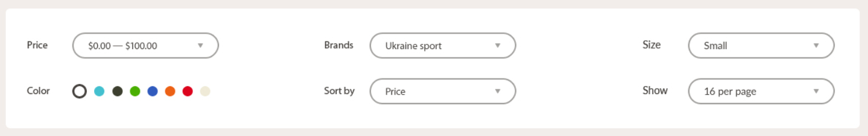

## Product Detailed Page

* 1. **Product Image**

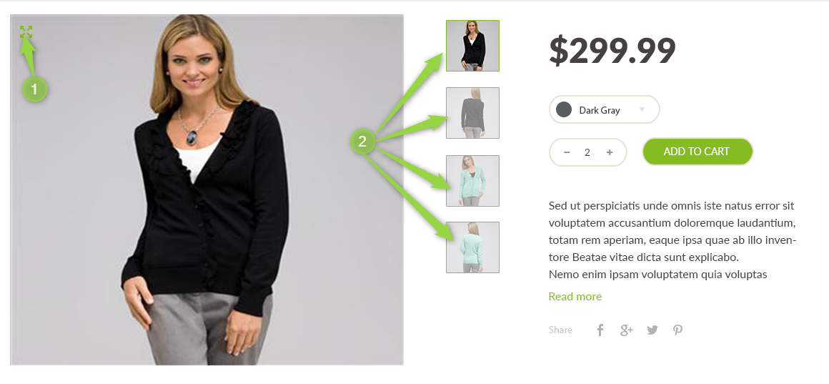

1. *PRODUCT_IMG_1*. Zoom button. By clicking on the button, open the full-page preview for main product image **(optional, bonus point).**
2. *PRODUCT_IMG_2*. Product Thumbnails. Clickable images, by clicking on any image, should be changed the main image. Also, active state required for current active image.
3. *PRODUCT_IMG_3.* All necessary images can be found under **version 0.4\jpg\1280\pdp-images** folder
   1. **Product Details**

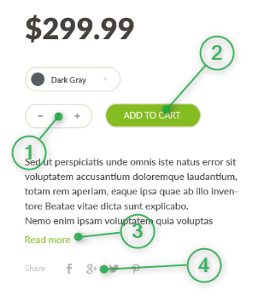

1. *PRODUCT_DETAILS_1*. Quantity field. The numeric input field (JS/jQuery validation required to accept only numbers, and don’t accept letters or any special characters). By clicking “+”, “-” button, accordingly increase/decrease the quantity.
2. *PRODUCT_DETAILS_2*. Add to cart button. Will act in the same way as *PRODUCT_TILE_4*, except the number for Minicart will be increased accordingly to the value from Quantity field from *PRODUCT_DETAILS_1*.
3. *PRODUCT_DETAILS_3*. Read More link. Expand the Product Description text. The initial limit to show no more than 100 characters. By clicking on the link, show remaining characters.
4. *PRODUCT_DETAILS_4*. Social icons. The links will redirect to dedicated social network page.
   1. **Tabs**

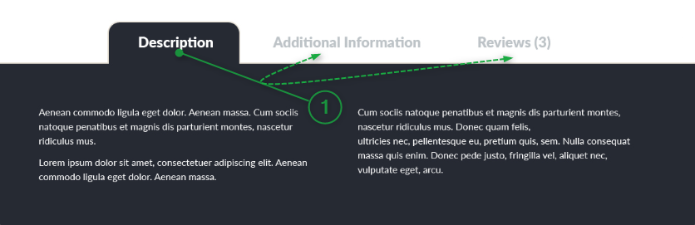

1. *PRODUCT_TABS_1*. Product Tabs. By clicking on any tab heading, dedicated tab content will become visible.

## Non-Product Pages

* 1. **404 Page (Static content)**



* 1. **Log in Dialog**

The dialog will be shown by clicking on the icon described in *HEADER_3*. Clicking on the overlay or pressing ESC key will close the modal.

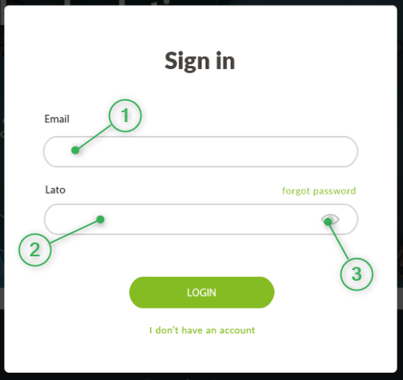

1. *LOGIN_MODAL_1*. Email input field. Email HTML5 validation required.
2. *LOGIN_MODAL_2.* Password field. HTML5 validation for password to contain: “At least 6 characters length, contain 1 numeric, 1 uppercase letter, 1 special character”.
3. *LOGIN_MODAL_3*. Password visibility toggle. By clicking on the button, will show/mask password entered.
   1. **Cookies Policy**

Cookie Policy Dialog will appear with the delay of 10 seconds, once the user is accessing the page. Should be used Browser Cookies or Local Storage to track this action.

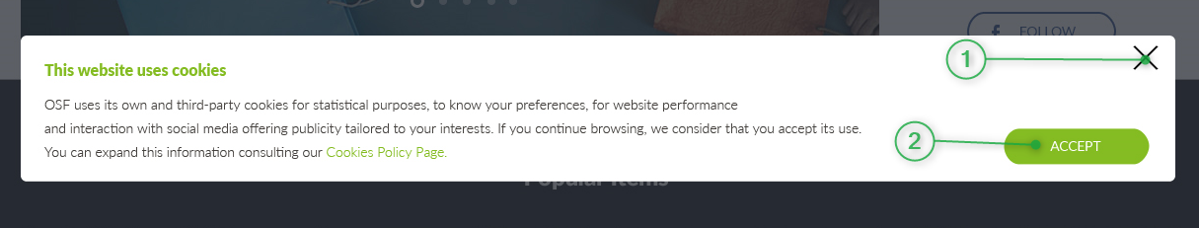

1. *COOKIE_1*. Close button. Once the user is clicking on the button, the dialog will be closed until next refresh of the page.
2. *COOKIE_2*. Accept Button. By clicking on Accept cookies policy button, the respective flag should be stored in Cookies or Local storage, to don’t show the dialog anymore. This will automatically appear once user will clear browser cache or open the page into Incognito window.
   1. **Countdown Page (bonus task. Requires basic skills of Node.js)**

Is required to add additional navigation link for current page.

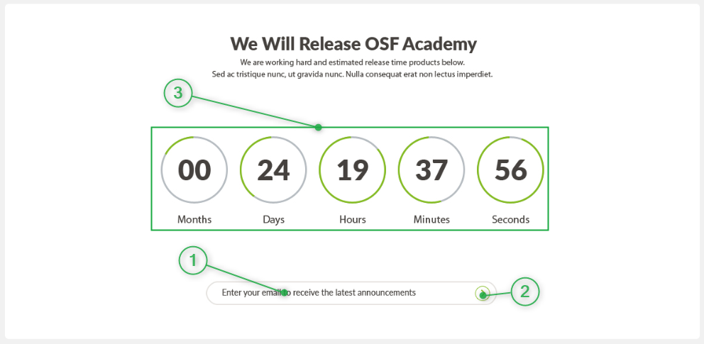

1. *COUNTDOWN_1*. Countdown time. Set the timer until the finish of your OSF Academy period.
2. *COUNTDOWN_2*. Email input. Email validation required.
3. *COUNTDOWN_3*. Submit button. On submit save the email address into a json file.
   1. **Cart Page (bonus task).**

Intern will adapt desktop design provided for mobile and tablet resolutions. The presentation decision for missing breakpoint is up to developer.

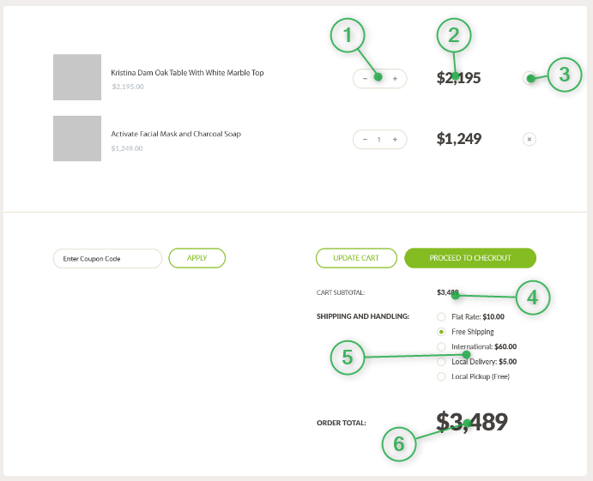

1. *CARTPAGE_1*. Quantity input. Will act in the same way as *PRODUCT_DETAILS_1*. Required to be used chosen framework binding and event handler.
2. *CARTPAGE_2*. The product prices. Must be updated accordingly quantity changing.
3. *CARTPAGE_3*. Remove product. By clicking on the button, the product must be removed from the list, and cart subtotal (CARTPAGE_4) and order total (*CARTPAGE_6*) price also updated accordingly.
4. *CARTPAGE_4*. Cart subtotal. The sum of the product prices in the list.
5. *CARTPAGE_5*. Shipping methods. Each method will have dedicated price, that will be included in the order total (*CARTPAGE_6*) price calculation.
6. *CARTPAGE_6*. Order Total. The sum of all products in the list, and the price from shipping method chosen.
   1. **Print Page (bonus task)**

Required to create additional button (following general site UI kit) on Product Details Page under the Read More link *PRODUCT_DETAILS_3*. By clicking on the button, will be triggered default browser Print functionality.



By printing the page, display only main information about the product, as breadcrumb, Product name, Product Image, thumbnails, price, etc. (as shown on the screenshot). All the rest element from page as Header, Footer, Tabs should NOT be printed.